Shop to fill the Pantry at FISH
FISH is in need of items that families generally purchase on their shopping list: Noodles, Pasta, Pasta Sauce, Canned Soups, Canned Vegetables, Canned Fruits, Rice, Breakfast Cereals, Canned Fish & Meat, Peanut Butter, Bathroom Tissue, etc..
When making out your weekly shopping list, buy one for your family and one for a FISH family.
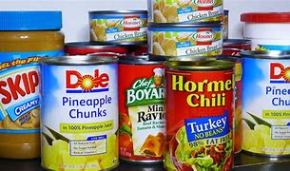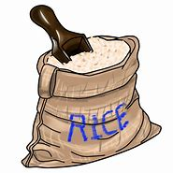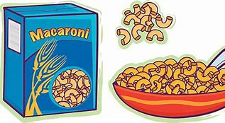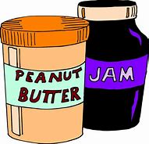

We will be accepting donations here at Trinity on Sunday mornings
(you may leave donations inside the vestibule of the Church)
or
on Saturday mornings from 9-11am in the Parish Hall.
Collection of items will end on Sunday, November 22.

